HUMAN-CENTERED DESIGN COMPETITION 2.0
Stage 1: Inspiration
Submission deadline: 28th February, 2024
Project Title:
Team Leader Name and Regd. No:
Mechatronics Engineering Department UET Lahore and MADE Foundation USA bring you the Human Centered Design Competition 2.0. This competition aims to foster innovation among the students of UET Lahore and create sustainable solutions that create real impact and generate viable business.
The human-centered design consists of three main stages:
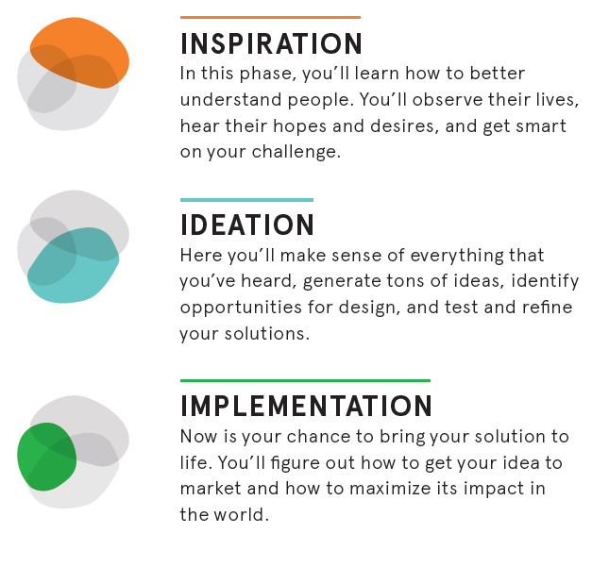
Figure 1: The three stages of Human Centered Design
The three stages of our competition represent these three stages of the Human Centered Design. For stage 1 of the competition, the participants must submit a concept note regarding the problem they intend to solve.
Please remember that your solutions should be desirable, feasible, and viable for them to have a true impact. In one sense, the three stages of Human Centered Design tackle the conversion of your idea into a desirable, feasible, and viable solution.
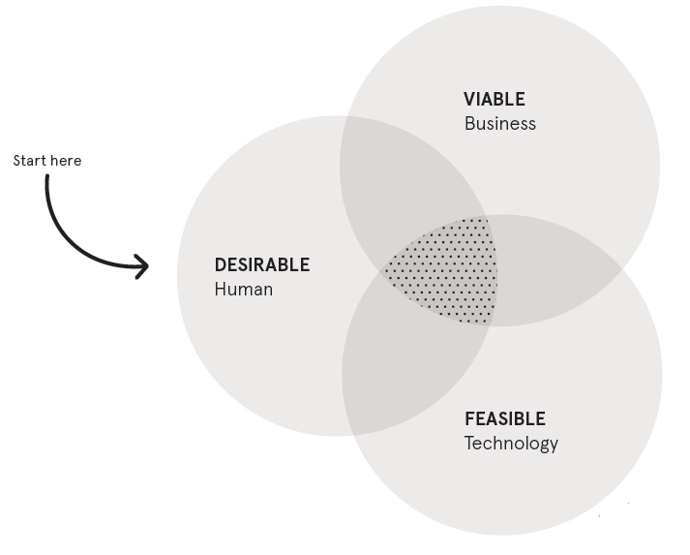
Figure 2:Ingredients of an impactful solution

INSPIRATION
The Inspiration phase is about learning on the fly, opening yourself up to creative possibilities, and trusting that if you remain grounded in the desires of the communities you’re engaging, your ideas will evolve into the right solutions. You’ll build your team, get smart on your challenge, and talk to a staggering variety of people.

STEP 1: Frame your Design Challenge
Organize your thoughts and think about the challenge and problem you are trying to solve. ask yourself: Does my challenge drive toward ultimate impact, allow for a variety of solutions, and consider context? Dial those in, and then refine it until it’s the challenge you’re excited to tackle. Don’t keep it too narrow or too broad. Go through these thoughts again and again until you have reached a viable conclusion. A quick test we often run on a design challenge is to see if we can come up with five possible solutions in just a few minutes.
Answer the following questions after giving it careful thought iteratively.

What is the problem you are trying to solve?
Apart from the problem description, try answering who faces it. what is the frequency of occurrence? why the currently available (if any) solutions lacking? etc.

- Take a stab at framing it as a design question, in one line.

- Now state the ultimate impact you’re trying to have.

- What are some possible solutions to your problem?
Think broadly. It’s fine to start a project with a hunch or two, but make sure you allow for surprising outcomes.

- Finally, write down some of the context and constraints that you’re facing.
They could be geographic, technological, time-based, or have to do with the population you’re trying to reach.

- Does your original question need a tweak? Try it again.

- Tell us a little bit about your final product that you imagine exhibiting in the final round.
Make it concise by incorporating the relevant information about software, hardware, and/or integrated hardware

STEP 2: Create a Project Plan
- Decide on your budget and staff. Do you have everything you need to complete the challenge?

- Identify who will visit to understand the problem better. How will the visits be arranged?

- Look at the core members of your team and determine what they’re good at and what they’re not so good at. List their core capabilities here:

STEP 3: Secondary Research
Along with the interviews and surveys, there will be moments where you’ll need more context, history, or data than a man-on-the-street style interview can afford. It’s time to start learning about the broader context.
- List recent innovations in your particular area. They could be technological, behavioral, or cultural.

- What alternate solutions are available in your area? Are there any that feel similar to what you might design?

- What is your value addition in the existing solution, your unique selling point?

STEP 4: Interviews
There’s no better way to understand the hopes, desires, and aspirations of those you’re designing for than by talking with them directly. Interviews are the crux of the Inspiration phase. Whenever possible, conduct your Interviews in the person’s space. You must categorize your extreme audience, and your main target audience and get samples from both in your interviews. It is also necessary to interview field experts who can guide you about the deeper context of the problem.
For a detailed guide on interviews, please refer to the “Field Guide to the Human-Centered Design” by IDEO. https://www.designkit.org/
Fill in the following interview guide:
Then Go Deep
What are some questions that can help you start to understand this person’s hopes, fears, and ambitions?
Open General
What are some broad questions you can ask to open the conversation and warm people up?

STEP 5: A pictorial collage
To showcase your efforts towards human-centered design, add a pictorial collage here that may showcase the problem, the people facing them, the interview process, design sketches, the work environment, etc.

STEP 6: Summarize
Summarize your initial findings here. Discuss about the following after reflecting on your efforts:
- Problem
- Target audience
- Indented Solution with initial design sketches
- Impact of the solution
- Your intended roadmap for the implementation of the solution.

